Adding Internet Advancement Calendars to Google Calendar, Phone or Tablet
(updated 8:43am 10/26/2023) Thanks to Seth Wilson for sharing his guide for subscribing to Scoutbook Calendars
Go to Internet Advancement and then the calendar page. Scroll down and after the calendar you will see URLs for the different calendars in your unit.
You can copy the URLs you need from there using the copy icon .
Modify the following guide with the ones you wish your parents to connect to. Then ask them to follow the instructions depending on the type of device that they have.
NOTE: Issues with subscriptions normally are because of how your phone or other 3rd party product works. Please check with them first if you run into difficulties.

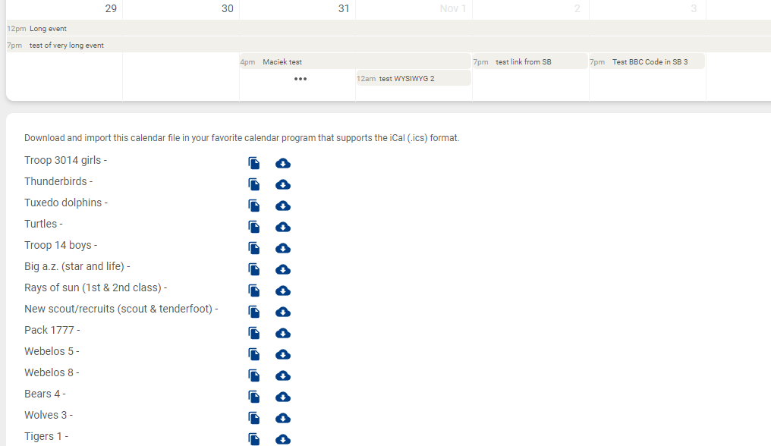
Adding Internet Advancement Calendars to Your Phone or Tablet
iOS (iPhone, iPad)
- Go to Settings > Calendar > Accounts > Add Account > Other.
- Tap Add Subscribed Calendar.
- Enter one of these URLs in the “Server” prompt:
  - https://apiqa.scouting.org/advancements/events/calendar/Example98 (Pack Calendar)
  - https://apiqa.scouting.org/advancements/events/calendar/Example99 (Pack Lion Den)
  - https://apiqa.scouting.org/advancements/events/calendar/Example96 Pack Tiger Den)
  - https://apiqa.scouting.org/advancements/events/calendar/Example95 (Pack Wolf Den)
- Leave all other settings as defaulted and tap Save.
- Repeat the process for any additional calendars you want added.
- In the Calendar App, adjust the color used to display Internet Advancement events by tapping “Calendars” at the bottom of the app, then the (i) button to the right of the subscribed calendar.
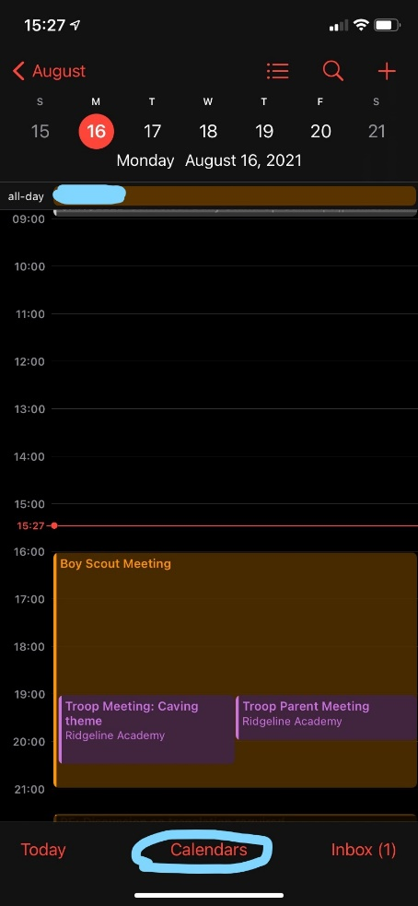
NOTE: Apple Calendar updates every 1-3 hours by default. You can chnge this setting on your iPhone or iPad. Open the Settings app. Tap Calendar

Android and Google Calendars
Calendars first need to be added to your Google Calendar on the web using the same account you sync with your phone:
  - Go to Google calendars and sign in to your account: https://www.google.com/calendar.
  - Click the down-arrow or + button next to Other calendars.
  - Select Add by URL or From URL from the menu.
  - Enter one of these URLs in the “URL of calendar” prompt:
  - https://apiqa.scouting.org/advancements/events/calendar/Example98 (Pack Calendar)
  - https://apiqa.scouting.org/advancements/events/calendar/Example99 (Pack Lion Den)
  - https://apiqa.scouting.org/advancements/events/calendar/Example96 Pack Tiger Den)
  - https://apiqa.scouting.org/advancements/events/calendar/Example95 (Pack Wolf Den)
  - Click Add calendar. The calendar will appear in the Other calendars section of the calendar list to the left.
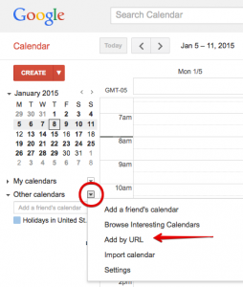
  - Open the Calendar app on your phone and see if the Internet Advancement calendars show. If not, click the hamburger button in the top left and check to see if the Internet Advancement calendar is listed and checked.
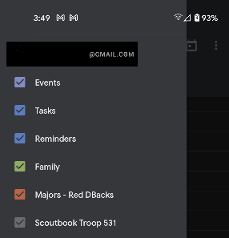

NOTE: Google Calendar updates subscribed calendars every 24 hours.

